Project Design Phase

Solution Architecture

|  |  |
| --- | --- |
| Date | 27 June 2025 |
| Team ID | LTVIP2025TMID32045 |
| Project Name | EduTutor AI: Personalized Learning with Generative AI and LMS Integration |
| Maximum Marks | 4 Marks |

Solution Architecture:

Solution architecture is a complex process – with many sub-processes – that bridges the gap between business problems and technology solutions. Its goals are to:

Purpose:

*EduTutor AI aims to deliver a personalized learning experience using generative AI. Its architecture connects users with language models through a lightweight interface, enabling concept explanation, grammar tutoring, and quiz generation from topics or PDFs — all without requiring complex backend frameworks.*

Architecture Overview:

The architecture is composed of the following layers:

User Interface Layer (Gradio)  
A no-code, interactive interface built entirely with Gradio Blocks, enabling:

Login/Register functionality

Concept input

Language selection

PDF upload for test generation

AI response display

Logic & Processing Layer (Python)

Handles user input, session management, and routing logic

Uses PyPDF2 to extract and process PDF content

Stores user session data and quiz state using Python dictionaries (user_sessions)

AI Model Layer (Hugging Face Transformers)

Integrates the IBM Granite 3.3-2B-Instruct model using Hugging Face pipeline

Performs text generation for:

Concept explanations

Grammar lessons (Hindi/English)

Quiz/test creation from topics or PDF inputs

Example - Solution Architecture Diagram:

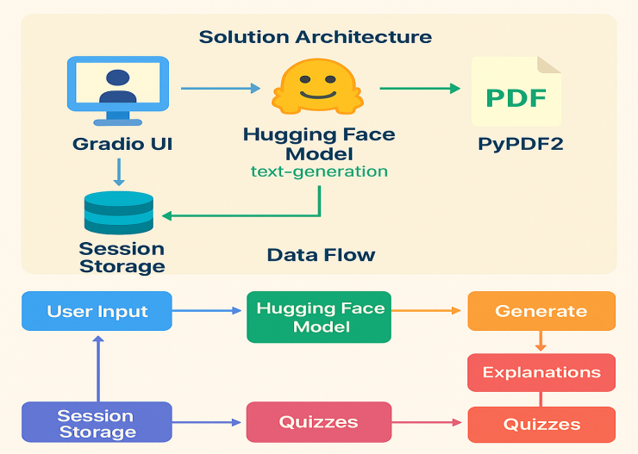

*Figure 1: Architecture and data flow of the EduTutor AI: Personalized Learning with Generative AI and LMS Integration.*